300986134 Parth Chandgadhiya

* Code 1:getting 10 number[print, min, max, avg].

using System;

using System.Collections.Generic;

using System.Linq;

using System.Text;

using System.Threading.Tasks;

using static System.Console;

namespace ConsoleApplication1

{

class Program

{

static void Main(string[] args)

{

double[] number = new double[10];

double sum = 0.00;

double average = 0.00;

for (int i = 0; i < number.Length; i++)

{

Write("Please enter your number {0}: ", i + 1);

number[i] = Convert.ToDouble(ReadLine());

}

WriteLine("\n\*\*\*\*\*\*\*\*\*\*\*\*\*\*\*\*\*\*\*\*\*\*\*\*\*\*\*\*\*\*\*\*\*\*\*\*\*\*\*\*\*\*\*\*\*\n");

for (int j = 0; j < number.Length; j++)

{

WriteLine("Your entered number {0} is := {1}", j + 1, number[j]);

sum += number[j];

}

average = sum / number.Length;

WriteLine("\n\*\*\*\*\*\*\*\*\*\*\*\*\*\*\*\*\*\*\*\*\*\*\*\*\*\*\*\*\*\*\*\*\*\*\*\*\*\*\*\*\*\*\*\*\*");

WriteLine("\nMaximum number that you have entered is {0}\n",number.Max());

WriteLine("\*\*\*\*\*\*\*\*\*\*\*\*\*\*\*\*\*\*\*\*\*\*\*\*\*\*\*\*\*\*\*\*\*\*\*\*\*\*\*\*\*\*\*\*\*");

WriteLine("\nMinimum number that you have entered is {0}\n", number.Min());

WriteLine("\*\*\*\*\*\*\*\*\*\*\*\*\*\*\*\*\*\*\*\*\*\*\*\*\*\*\*\*\*\*\*\*\*\*\*\*\*\*\*\*\*\*\*\*\*");

WriteLine("\nSum of all of the entered numbers is {0}\n", sum);

WriteLine("\*\*\*\*\*\*\*\*\*\*\*\*\*\*\*\*\*\*\*\*\*\*\*\*\*\*\*\*\*\*\*\*\*\*\*\*\*\*\*\*\*\*\*\*\*");

WriteLine("\nAverage of all numbers is = {0}\n", average);

WriteLine("\*\*\*\*\*\*\*\*\*\*\*\*\*\*\*\*\*\*\*\*\*\*\*\*\*\*\*\*\*\*\*\*\*\*\*\*\*\*\*\*\*\*\*\*\*");

}

}

}

Output: -

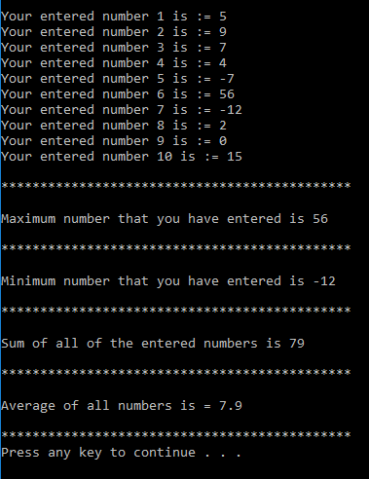

* Code 2: - function for power MyPow().

using System;

using System.Collections.Generic;

using System.Linq;

using System.Text;

using System.Threading.Tasks;

using static System.Console;

namespace ConsoleApplication1

{

class Program

{

static void Main(string[] args)

{

double a = 0;

double b = 0;

double answer;

Write("Please enter your base number: ");

a = Convert.ToInt32(ReadLine());

Write("\nPlease enter power: ");

b = Convert.ToInt32(ReadLine());

answer = MyPow(a,b);

WriteLine("\n{0} to the power of {1} is equal to = {2}\n",a,b,answer);

}

static double MyPow(double x, double y)

{

x = Math.Pow(x, y);

return (x);

}

}

}

Output: -

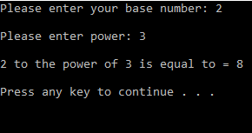

* Code 3: - Function for maximum MyMax().

using System;

using System.Collections.Generic;

using System.Linq;

using System.Text;

using System.Threading.Tasks;

using static System.Console;

namespace ConsoleApplication1

{

class Program

{

static void Main(string[] args)

{

double a = 0;

double b = 0;

double answer;

Write("Please enter your first number: ");

a = Convert.ToDouble(ReadLine());

Write("\nPlease enter your second number: ");

b = Convert.ToDouble(ReadLine());

answer = MyMax(a,b);

WriteLine("\nMaximum number from {0} and {1} is: {2}\n",a,b,answer);

}

static double MyMax(double x, double y)

{

double bigger;

if (x > y)

{

bigger = x;

}

else

{

bigger = y;

}

return (bigger);

}

}

}

Output: -

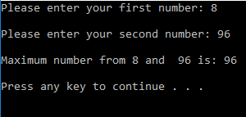

* Code 4: -Function for average MyAvg().

using System;

using System.Collections.Generic;

using System.Linq;

using System.Text;

using System.Threading.Tasks;

using static System.Console;

namespace ConsoleApplication1

{

class Program

{

static void Main(string[] args)

{

double a = 0;

double b = 0;

double c = 0;

double answer;

Write("Please enter your first number: ");

a = Convert.ToDouble(ReadLine());

Write("\nPlease enter your second number: ");

b = Convert.ToDouble(ReadLine());

Write("\nPlease enter your thrid number: ");

c = Convert.ToDouble(ReadLine());

answer = MyAvg(a,b,c);

WriteLine("\nAverage of all of your entered number is {0} \n",answer);

}

static double MyAvg(double x, double y,double z)

{

double avg = ((x+y+z) / (3));

return (avg);

}

}

}

Output: -

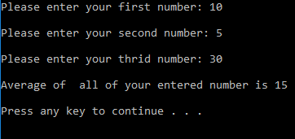

* Code 5: -Function for factorial MyFact().

using System;

using System.Collections.Generic;

using System.Linq;

using System.Text;

using System.Threading.Tasks;

using static System.Console;

namespace ConsoleApplication1

{

class Program

{

static void Main(string[] args)

{

int a ;

int answer;

Write("Please enter your number: ");

a = Convert.ToInt32(ReadLine());

answer = MyFact(a);

WriteLine("\nFactorial of {0} is : {1} \n",a,answer);

}

static int MyFact(int x)

{

int factorial = 1;

for (int i = 1; i <= x ; i++)

{

factorial \*= i;

}

return (factorial);

}

}

}

Output: -

